**CAPSTONE PROJECT REPORT**

**FACE DETECTION AND RECOGNITION**

**Name:** Abhinav Ankur

**Course:** AI and ML (Batch 3)

**Problem Statement:** Build a machine learning model for Face Detection and Recognition

**Prerequisites:**

Python 3.6: This setup requires that your machine has latest version of python. The following url https://www.python.org/downloads/ can be referred to download python. Once you have python downloaded and installed, you will need to setup PATH variables (if you want to run python program directly, detail instructions are below in how to run software section). To do that check this: https://www.pythoncentral.io/add-python-to-path-python-is-not- recognized-as-an-internal-or-external-command/. Setting up PATH variable is optional as you can also run program without it and more instruction are given below on this topic.

Anaconda: Download anaconda and use its anaconda prompt to run the commands. To install anaconda check this url https://www.anaconda.com/download/ You will also need to download and install below 3 packages after you install either python or anaconda from the steps above Sklearn (scikit-learn) numpy scipy if you have chosen to install python 3.6 then run below commands in command prompt/terminal to install these packages pip install -U scikit-learn pip install numpy pip install scipy if you have chosen to install anaconda then run below commands in anaconda prompt to install these packages conda install -c scikit-learn conda install -c anaconda numpy conda install -c anaconda scipy

**Dataset Used:**

The data source used for this project is captured from live images using opencv module. The screenshot of the process is shared.

**Libraries Used:**

OpenCV

os

numpy

PIL

Matplotlib

Keras

**Method for Face Detection:**

Haarcascade Classifier is used here to detect faces.

**Working:**

**Importing Libraries and Datagen Declaration:**

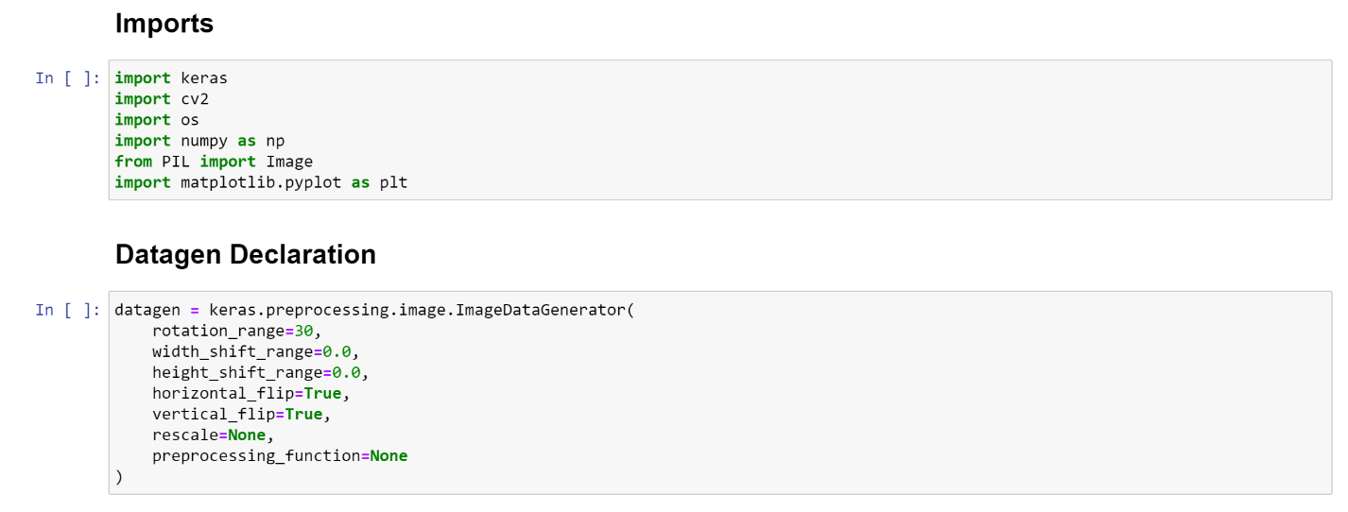

**Function for capturing image for ID:**

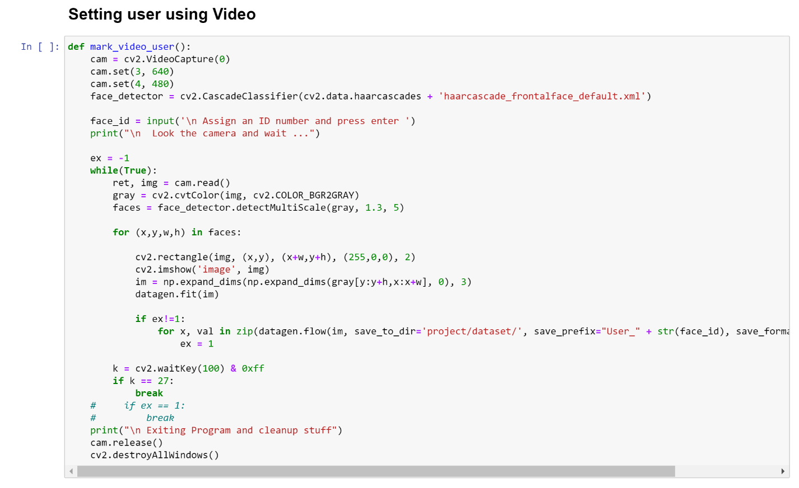

**Training the data:**

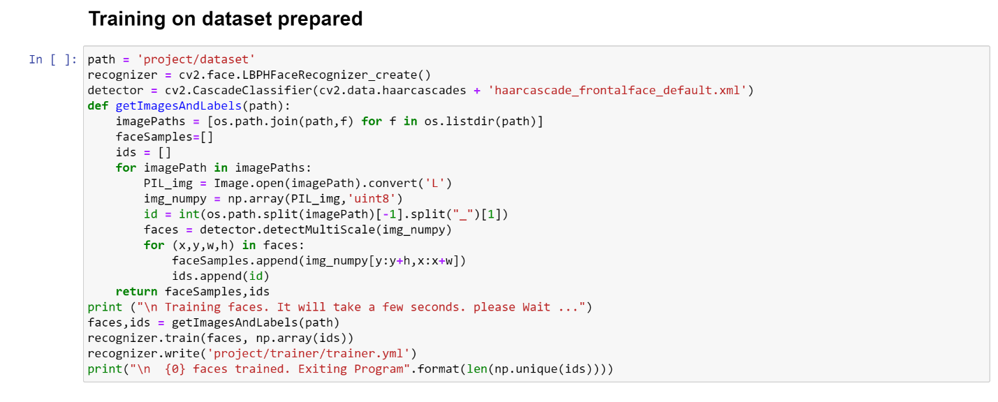

**Recognition:**

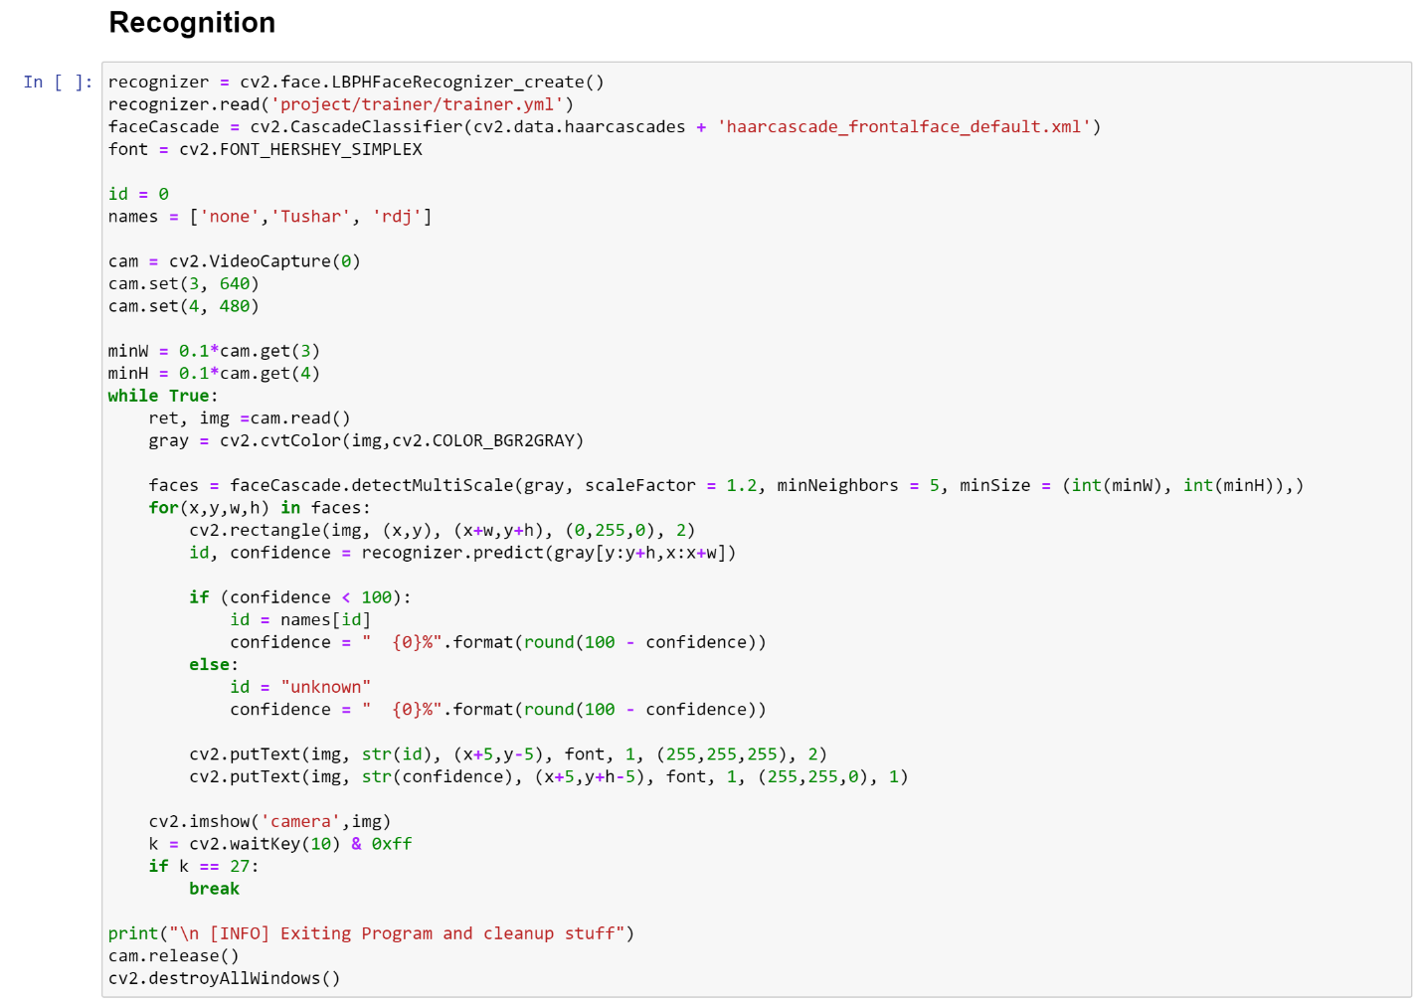

**Output while capturing the image for the dataset:** 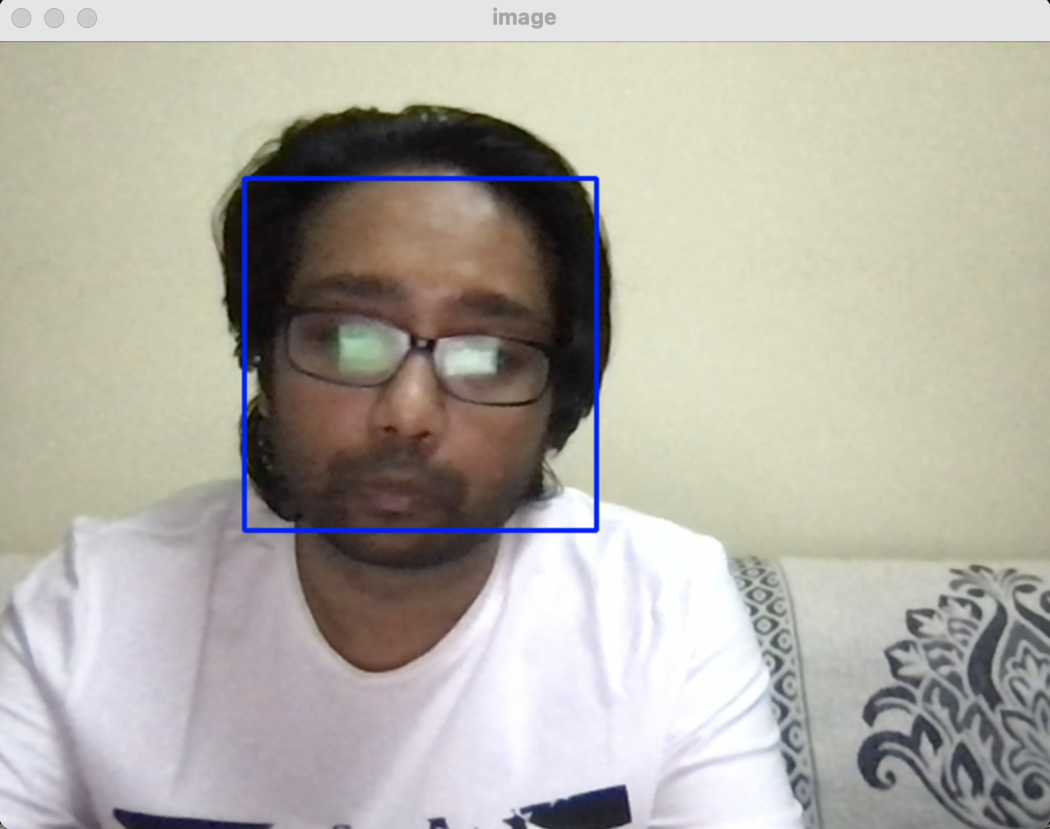

**Final Output:**

